Rohan Patel

Daniel Nazarian

Kyle Romm

Jamie Maignan

Group 9

Home Quiz 4

Bugs App from Mike and Ethan

The app consists of a navigation bar at the top, allowing the user to navigate between the different bugs by swiping on the screen. Under the navigation bar, there is a photo of the bug, and text about the bug. In the app, Mike and Ethan use the MainActivity class to display the information about each of the bugs. They use the BugsReciever class to control the titles at the top of the app, where the user can navigate to the certain bug they would like information about by swiping on the screen. They also use the BugsReciever class to control the order of the bugs displayed in the top bar on the screen. The settings button doesn’t provide any functionality at the time.

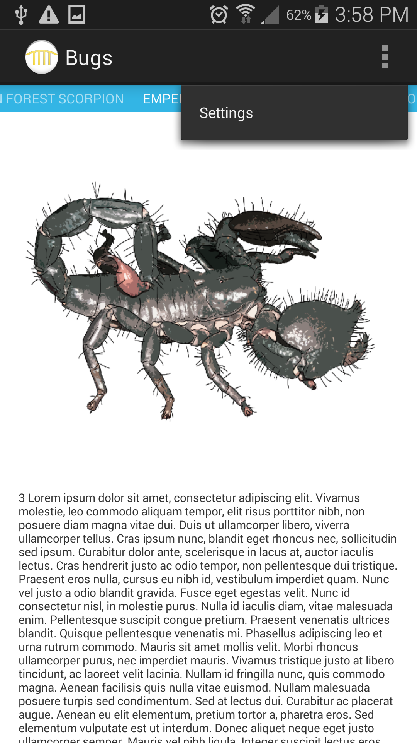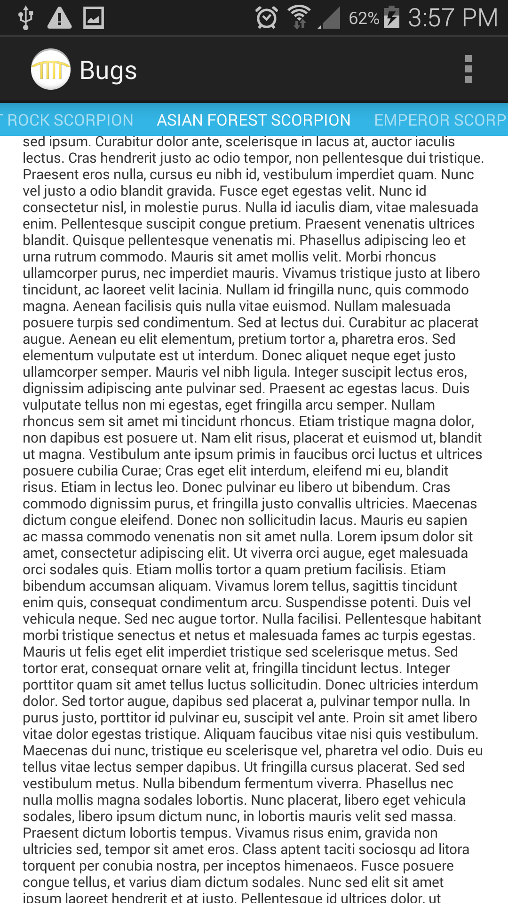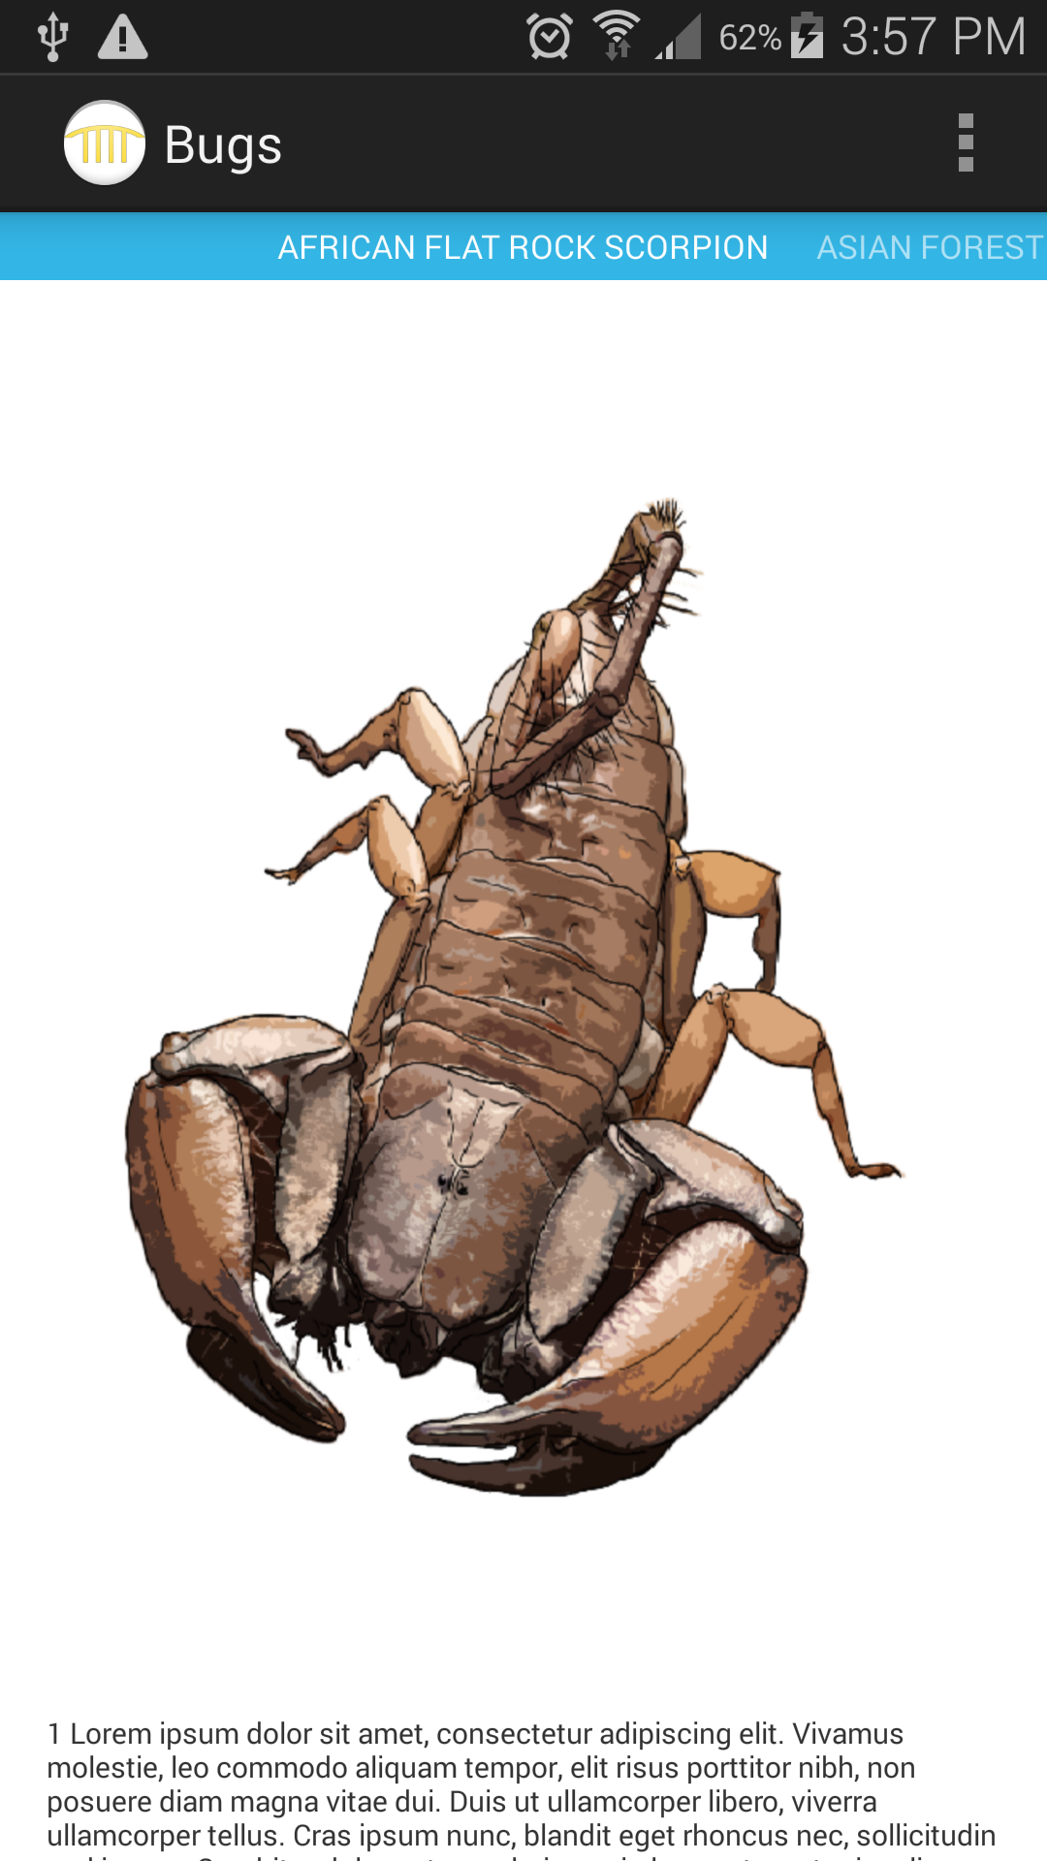

MODS App:

When opening the app, the user is prompted with a main screen that offers the user options, such as floor plans. Once clicking on floor plans, they are given the choice to choose the map they would like. Another feature allows the user to browse through different creatures in each exhibit, with a photo of the animal. A popup window also prompts the user with an interesting fact about the animal 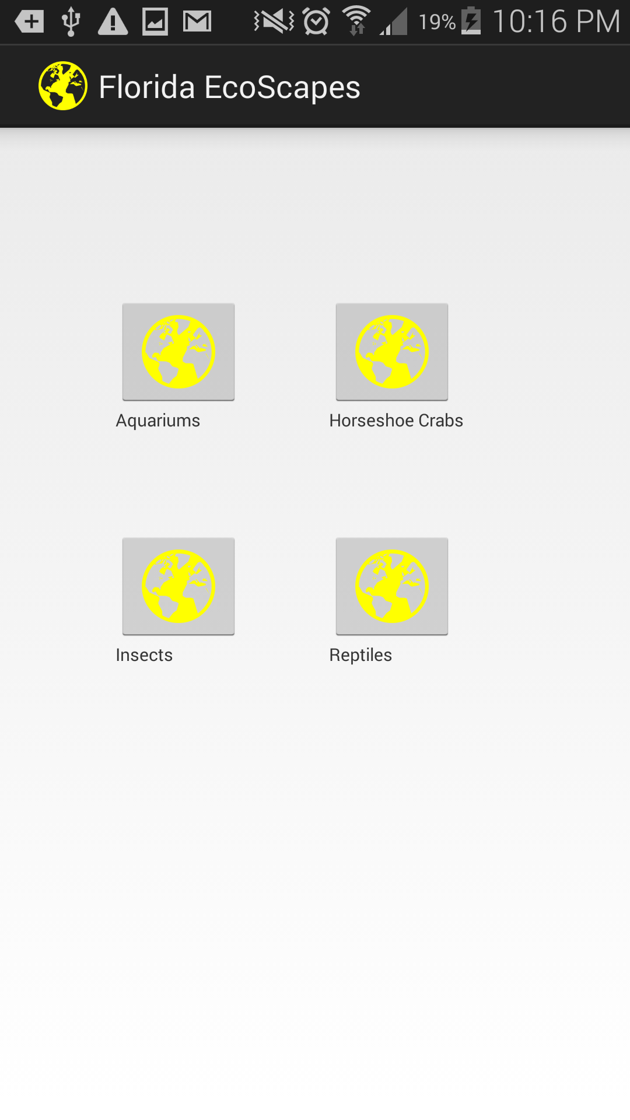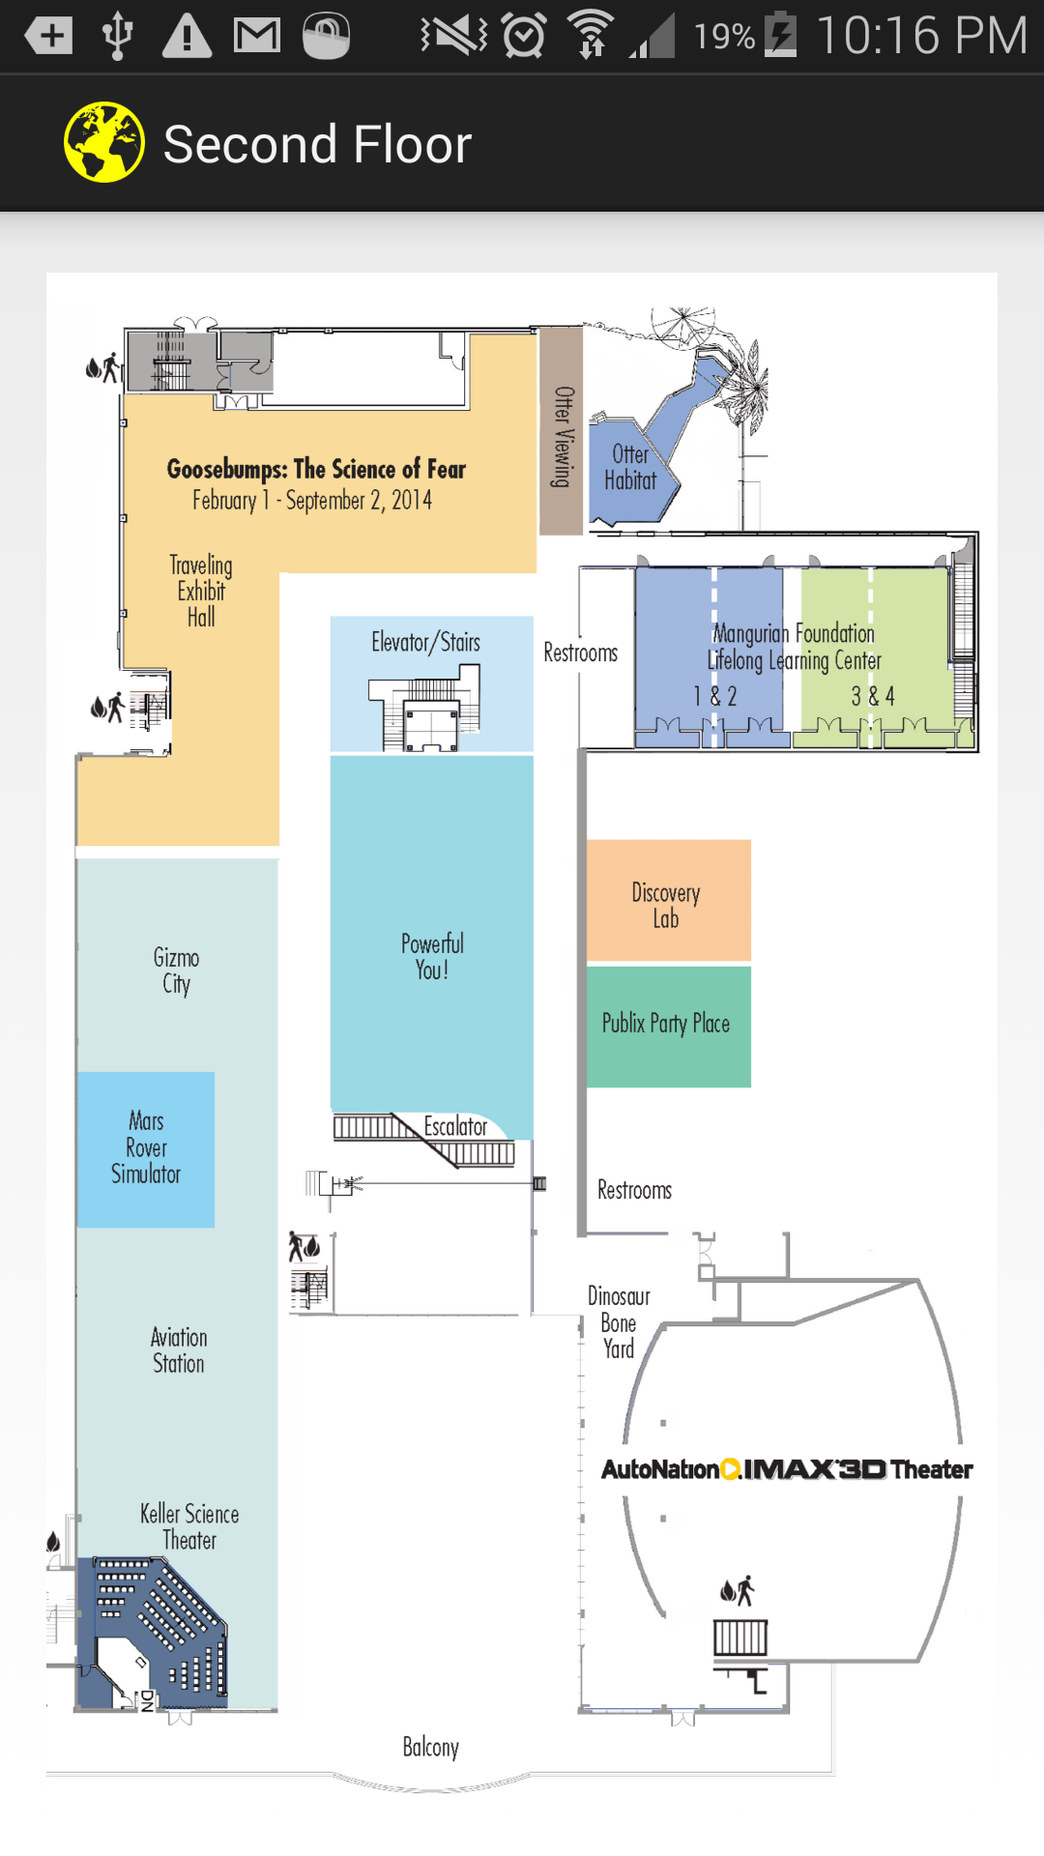mentioned on the screen.

Detect Robot:

Initially, the app displays a blank screen, until the user taps on the screen. The camera is then activated and a preview is shown on the screen. The camera takes photos with a frame rate of 10 frames per second. To take a picture, the user just taps the screen, and the picture taken replaces the preview. The app analyzes the picture and replaces green pixels with purple dashes.

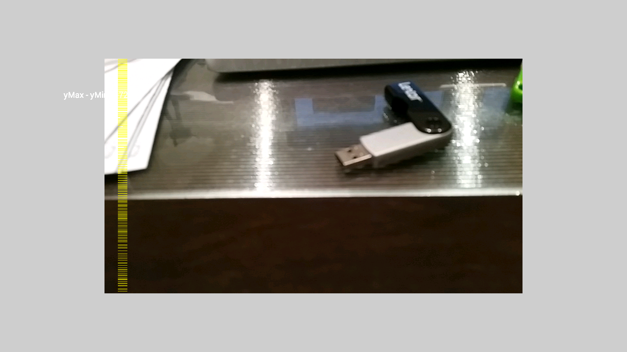

The Detect Robot app also measures distances with the camera. On the left, in white font next to the yellow dashes, the distance from the longest green object to the camera. The distance is printed on the left in cm.

